OCEANA COUNTY 4-H MARKET LIVESTOCK
EDUCATIONAL NOTEBOOK/RECORD

GOAT PROJECT- 2024

AGES 15-19
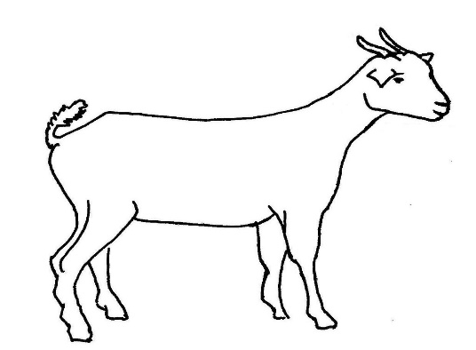
This Photo by Unknown Author is licensed under CC BY-SA-NC
As a member of the 4-H Market Livestock Goat project you are required to submit your records as part of an educational notebook project in order to sell your animal at the 4-H Market Livestock Sale. This notebook must be shown to the Oceana County 4-H Market Livestock Committee's Weighmaster at the time of weigh-in and then entered by you in the Educational Notebook Division of the Oceana County Fair on Entry Day.

AGE: _____

The age you enter depends on how old you are or will be on Jan. 1, 2024

Number of years in project: _____

If you are a little buddy, who is your big buddy: __________________________________

NAME________________________________________________________________________

4-H CLUB_____________________________________________________________________

BREED________________________________GOAT’S NAME__________________________

DATE OF BIRTH___________________ DATE RECORD STARTED_____________________

LOCATION WHERE ANIMAL IS RAISED __________________________________________

JUDGE’S SCORE/COMMENT SHEET

(PLEASE DO NOT REMOVE, PLACE THIS SHEET IN SHEET PROTECTOR OR GLUE TO COVER). This sheet must be keep free to the judge to write their comments.

This sheet should help each 4-H’er understand their ribbon placing.

A. Specific educational value or worth

___ All questions were answered completely

___ All calculations were correct

___ Calculations were incorrect

___ Questions were not completely answered

___ Questions were not answered (missed questions)

B. Notebook contains all project records

___ Notebook contained all project records and were fully completed.

___ Notebook contained additional project related information (research materials
etc.).

___ Project records were incomplete

___There was no additional project related information

C. Accuracy, neatness and general appearance

___Notebook was neat in appearance (typed/hand printed)

___ Notebook pages were clean and stain free

___Notebook pages were in order and complete

___Notebook pages were out of order and missing pages

___Notebook was difficult to read and messy

___Notebook had wrinkled and stained pages

Other Comments: ________________________________________________________

_______________________________________________________________________

_______________________________________________________________________

4-H MARKET LIVESTOCK GOAT NOTEBOOK- 2024
AGES 15-19

TABLE OF CONTENTS
Please keep your notebook in Table of Contents order.

- GENERAL GUIDELINE INFORMATION

- JOURNAL OF CARE

- PROJECT INFORMATION

- SPECIFIC PROJECT KNOWLEDGE
  - Breed Scramble
  - Marketing
c) Goat Parts Identification
d) Fitting & Showing
e) Wholesale Cuts
f) Sheep By-Products

- YOUR PROJECT INFORMATION
  - Project Progress & Management Info
  - 4-H Activities

- BUYERS NAMES

- PICTURES OF YOUR PROJECT (1 page)

- NON-CLUB/CLUB POINTS SHEETS

APPENDIXES (OPTIONAL):

- PICTURES OF YOUR PROJECT (additional pictures)
- FEED INFORMATION (example: Feed labels etc.)
- ADDITIONAL INFORMATION ABOUT YOUR PROJECT
  - Information you found in reference materials
  - Information you located off the internet
  - Information gathered from your feed representative
  - Any other information
* Include notes as to why you researched this information and found it valuable, link it to your project if possible.

Notebook Resources:
Meat, Goat Helper’s Guide National 4-H Curriculum
Getting Your Goat National 4-H Curriculum
Farm Credit Knowledge Center (www.FarmCreditofVirginias.com/Klowledge-Center)

2024-Goat Record Book (15-19) Page 1

This record book is part of your 4-H Market Goat Project. By keeping records up to date you will be able to see how much progress you make as you set goals and work to accomplish them. Write neatly and clearly. Feel free to add extra pages.

PROJECT PICTURES

Pictures are a required part of this notebook. Taking pictures of your project animal throughout the project will indicate how your animal has grown and developed. Add pictures to your notebook on a separate piece of paper.

SCORING CRITERIA

The following breakdown will be used during the judging process of all market livestock notebooks.

A. Specific educational value or worth 30%

B. Creative way of showing what has been learned 10%

C. Notebook contains all project records 50%

D. Accuracy, neatness and general appearance 10%

The Oceana County 4-H Market Livestock Committee encourages 4-H Leader and parent assistance with your project and project notebook. If you should have any questions, please contact the MSU Extension Office.

I, ____________________________ assisted ________________________ in
Parent/Leader/Adult Name 4-Her’s Name
understanding the questions and writing the answers. All answers are those of the 4-Her.

____________________________________
Signature of person helping with notebook
If written help was needed

2024-Goat Record Book (15-19) Page 2
JOURNAL OF CARE

The 4-H Market Livestock Committee is requiring all 4-H Market Livestock members to complete the “Journal of Care”, so the judge may see the time, effort and care you have put into learning about your animal.

** It will be assumed that you walked & fed your animal, but what additional
things have you done such as: washed, clipped, trimmed, foot care, health practices, medicines, general maintenance (cleaning living area & feed pans) halter breaking, training, had vaccinated, etc. **
APRIL:

MAY:

JUNE:

3

2024-Goat Record Book (15-19) Page 3

JOURNAL OF ANIMAL CARE
(cont.)

JULY:

AUGUST:

I, ___________________________, do attest and certify that this 4-Her has cared for this
(property owner name (please print))
animal in a responsible manner while housed on my property. I also understand that integrity and responsibility are important to this 4-H experience.

______________________________________ ______________
Signature of Property Owner Date
(if housed at home have parent sign)

2024-Goat Record Book (15-19) Page 4

PROJECT INFORMATION

The start of the project will be the date the exhibitor placed the animal on feed. The end of the project will be weigh-in at fair.

Project Start Date June 1, 2024 Project End Date ______________________
Fair Haul In Day
What month was your Goat born? ____________________________________________

Please fill in the following information about your Goat.

Ear Tag  Number | Breed | Gender | Date of Purchase | Price or Value | Estimated Starting Weight | Ending/Final Weight  (FW) | Total Pounds Gained
Note: Total pounds gained = ending weight – starting weight
Month | Type of feed used-  (grain, roughage, etc.) | Supplements  (if any used) | Amount (indicate lbs., bales, etc.) | Cost or Value of feed used for the month
April
May

MONTHLY FEED RECORD & EXPENSES
2024- Goat Record Book (15-19) Page 5

MONTHLY FEED RECORD & EXPENSES (cont.)

Month | Type of feed used-  (grain, roughage, etc.) | Supplements  (if any used) | Amount (indicate lbs. bales, etc.) | Cost or Value of feed used for the month
June
July

August

Column Totals

Total Feed Costs for Project: $ _____________
2024-Goat Record Book (15-19) Page 6
EXPENSES OTHER THAN FEED

The 4-H Market Livestock Committee would like you to keep a running list of all of your expenses -- veterinary charges, bedding, insecticides, trucking, insurance, interest paid on money borrowed, housing etc. Even if your animal was given to you, or bought by your parents, there is always a cost of an animal!

 | Vet  Charges | Bedding | Insecticides | Equipment | Trucking | Housing rent | Shearing or Clipping | Advertising/  Marketing | Miscellaneous (specify) | Buyer  Recognition | MONTHLY TOTAL
APR
MAY
JUNE
JULY
AUG
4-H FEE
TOTALS

2024-Goat Record Book (15-19) Page 7

PROJECT EFFICIENCY INFORMATION

Value of Animal at Time of Purchase = ___________

__________________ ÷ _______________ = ____________________________
Total lbs. of Gain Days on Feed Average Daily Rate of Gain
(from page 4)

_______________ ÷ ___________________ = ___________________________
Total Feed Cost Total lbs. of gain Feed Cost per Lbs. of Gain

______________________ ÷ __________________ = ___________________________
Total lbs. of feed fed Total lbs. of gain Lbs. of Feed fed per lb. of Gain

_________________ + ______________ + ________________ = _________________(TE)
Total Feed Expense Cost of Animal Other Expenses Total Project Expense

Goats are sold by the pound at a Large Animal Meat Sale Auction. Find out what bid price (per lb.) you need to get at the Large Market Auction to break even (BE) on your market Goat Project.

_______________ ÷ _________________ = ______________________________________
Total Expenses (TE) Final Weight (FW) Break Even Price (BE)
(or total cost per pound to raise your animal)

What is the current selling price of Goat (per lb.)? ___________________________________

Where did you find the current selling price? ________________________________________

_______________________________________________________________________________

_______________________________________________________________________________
(if your source was a person, ask them where they got this information)

Would you have been able to make a profit selling on the open market? _______________

2024-Goat Record Book (15-19) Page 8

PROJECT KNOWLEDGE

Parts of a Meat Goat 15-19 name all parts

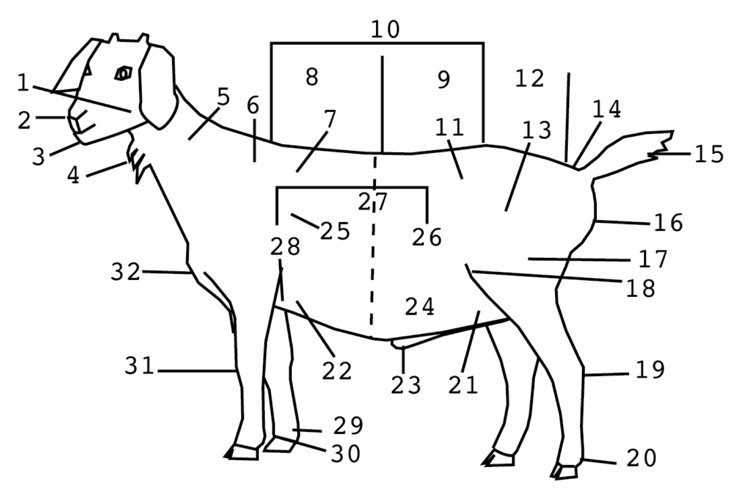
1.______ 9.______ 17._____ 25._____

2.______ 10._____ 18._____ 26._____

3.______ 11._____ 19._____ 27._____

4.______ 12._____ 20._____ 28._____

5.______ 13._____ 21._____ 29._____

6.______ 14._____ 22._____ 30._____

7.______ 15._____ 23._____ 31._____

8.______ 16._____ 24._____ 32._____

2024-Goat Record Book (15-19) Page 9

MARKETING

One of the most important parts of any market animal project is marketing. This may include letter writing, talking to buyers and making sure that you thank previous buyers in a timely and appropriate fashion. You should NOT scribble a thank you on paper, not go in person to thank your buyer, etc. An appropriate thank you is a requirement.

- What did you do to market your animal this year? Did you do anything differently than before, if you participated in the past?

____________________________________________________________________

____________________________________________________________________

____________________________________________________________________

____________________________________________________________________
STRUTCTURAL SOUNDNESS- Legs/Stance Front View

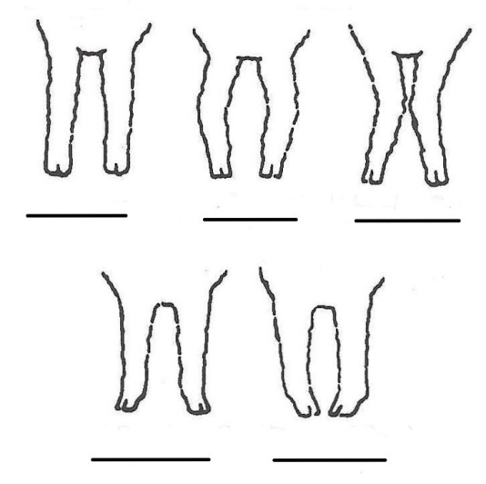
Which goat would you choose? Put the letter to the correct description under the correct view.

A. KNOCK-KNEED

B. PIGEON-TOED

C. CORRECT

D. SPLAYFOOTED

E. BOWLEGGED

2024-Goat Record Book (15-19) Page 10

WHOLESALE CUTS
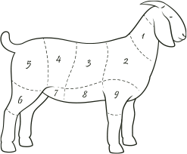
Write the letter that corresponds to the correct WHOLESALE cuts:

_____ Loin _____ Neck

_____ Shoulder _____ Leg

_____ Flank _____ Breast

_____ Rib _____ Foreshank

_____ Hindshank

Goat By Products Word Search
S | H | O | E | S | D | K | P | N | O | G | Y
L | Y | A | N | O | R | H | Z | L | W | L | V
J | C | E | X | A | U | T | M | E | X | O | R
F | Z | T | B | P | M | A | Q | A | B | V | T
H | L | N | S | K | S | B | U | T | T | E | U
U | J | E | K | R | J | Y | O | H | I | S | B
B | C | A | S | H | M | E | R | E | E | R | C
B | E | M | R | V | D | G | E | R | U | O | N
K | G | E | Y | N | I | H | S | O | G | H | J
F | D | J | C | Y | C | A | N | D | L | E | S
S | O | P | W | V | F | P | I | N | D | F | C
Word Bank:
Butter Gloves
Candles Leather
Cashmere Shoes
Drums Soap

2024-Goat Record Book (15-19) Page 11
Breed Word Search

J | S | T | I | F | F | L | E | G | A | C | M | Z
N | L | W | T | N | A | I | E | V | E | D | A | T
E | W | F | N | Y | I | E | S | U | C | D | T | P
R | D | S | P | A | N | I | S | H | M | E | K | C
V | S | M | F | C | T | N | E | M | A | I | X | A
O | V | A | F | R | I | C | A | N | D | E | R | I
U | O | J | A | C | N | G | A | F | M | Y | A | L
S | C | A | R | E | G | O | A | T | V | S | B | G
G | Z | Y | K | J | G | E | Z | U | P | Q | O | I
O | A | F | O | W | O | O | D | E | N | L | E | G
A | L | U | P | K | A | C | J | E | P | W | R | B
T | G | M | Y | O | T | O | N | I | C | P | A | E
Z | A | V | G | W | V | Y | U | C | S | D | E | S
C | I | W | M | N | K | Z | B | R | U | S | H | E
K | Q | E | Y | P | I | H | I | X | I | R | I | Y
B | I | H | C | V | K | W | A | E | Z | I | D | T
F | A | L | L | D | O | W | N | G | O | A | T | N
Word Bank:
-Africander -Kiko -Boer
-Scare Goat -Pigmy -Myotonic
-Brush -Spanish -Nubian
-Wooden Leg -Nervous Goat -Stiff Leg
-Fainting Goat -Wooden Leg

2024-Goat Record Book (15-19) Page 12

Project Progress and Management Record

1. What did you have the most fun doing with your market Goat project?

________________________________________________________________________________________________

________________________________________________________________________________________________

________________________________________________________________________________________________

2. What was the hardest part of your market Goat project?

________________________________________________________________________________________________

________________________________________________________________________________________________

________________________________________________________________________________________________

3. What are 2 marketable features of your animal that you would share with potential buyers?

________________________________________________________________________________________________

________________________________________________________________________________________________

________________________________________________________________________________________________

4. What feature(s) of your market Goat could use improvement?

________________________________________________________________________________________________

________________________________________________________________________________________________

________________________________________________________________________________________________

_______________________________________________________________________________

2024-Goat Record Book (15-19) PAGE 13
4-H ACTIVITIES

Number of club meetings held: _______ Number you attended: _______

List any club activities in which you have:
- participated in
- responsibilities which you have assumed
(for example: Community service events, workshops, judging contest, clinics, offices held, parades representing 4-H, etc.)

Activity | Date | Location | Placing, Position or Comments

The 4-H Pledge -write in the (8) Missing Words

I Pledge:
My _____________________________ to clearer thinking,
My ______________________________ to greater loyalty,
My ______________________________ to larger service, and
My ______________________________ to better living,
For my ________________________, my ___________________________________,
my___________________________, and my ________________________________.

2024-Goat Record Book (15-19) PAGE 14

POTENTIAL BUYER’S NAMES

As part of your 4-H Market Livestock Project, you must personally contact at least five potential buyers before the Oceana County Fair. You are encouraged to seek two new buyers that have not been asked or submitted before. You also must have at least three different buyers than those of your siblings in the market livestock project. Please confirm with your buyers their accurate mailing address (example: post office box vs. a street address). The information on page 17 must be completed and taken to the Oceana County MSU Extension Office on or before the due date where it will be copied and used to send out letters to your potential buyers. This page will remain in your notebooks. This is a Market Livestock Committee rule. Failure to comply will result in not being able to sell your animal in the 4-H Market Livestock Sale.

2024-Goat Record Book (15-19) Stamp _______________
PAGE 15 Staff _______________

4-H MARKET LIVESTOCK POTENTIAL BUYER’S LIST
GOAT PROJECT (AGES 15-19)

Name______________________________ Club_________________________
Please print business names and complete addresses clearly.

  - Contact Name ____________________________________________________

Business Name ____________________________________________________

Mailing Address _________________________City_________________Zip_____

Phone _______________________ After Hours Phone______________________
Mailing Preference (Please Check One): Email ____ Postal Delivery ____

Email ____________________________________________________________

Signature__________________________________________________________

2. Contact Name ____________________________________________________

Business Name ____________________________________________________

Mailing Address _________________________City_________________Zip_____

Phone _______________________ After Hours Phone______________________
Mailing Preference (Please Check One): Email ____ Postal Delivery ____

Email ____________________________________________________________

Signature__________________________________________________________

3. Contact Name ____________________________________________________

Business Name ____________________________________________________

Mailing Address _________________________City_________________Zip_____

Phone _______________________ After Hours Phone______________________
Mailing Preference (Please Check One): Email ____ Postal Delivery ____

Email ____________________________________________________________

Signature__________________________________________________________

(Must be stamped by the MSU Extension Office)

2024-Goat Record Book (15-19) Stamp _______________
PAGE 16 Staff _______________

If you would like to contact additional buyers you can use this page. If not please throw this page out.

Contact Name ____________________________________________________

Business Name ____________________________________________________

Mailing Address _________________________City_________________Zip_____

Phone _______________________ After Hours Phone______________________
Mailing Preference (Please Check One): Email ____ Postal Delivery ____

Email ____________________________________________________________

Signature__________________________________________________________

Contact Name ____________________________________________________

Business Name ____________________________________________________

Mailing Address _________________________City_________________Zip_____

Phone _______________________ After Hours Phone______________________
Mailing Preference (Please Check One): Email ____ Postal Delivery ____

Email ____________________________________________________________

Signature__________________________________________________________

Contact Name ____________________________________________________

Business Name ____________________________________________________

Mailing Address _________________________City_________________Zip_____

Phone _______________________ After Hours Phone______________________
Mailing Preference (Please Check One): Email ____ Postal Delivery ____

Email ____________________________________________________________

Signature__________________________________________________________

2024-Goat Record Book (15-19) PAGE 17

YOUR PROJECT PICTURES
Please use this page for your project pictures. If you have more than 1 page of pictures please use the appendix section to include those pictures.

NON-CLUB POINTS

8 YEARS OLD & UP MUST COMPLETE- MARKET LIVESTOCK ANIMAL ASSOCATION PROJECT ATTENDANCE RECORD
(This must be filled out before presenting for signatures at the office.)
MEETING NAME | LOCATION | DATE | POINTS | SIGNATURE OF LEADER, SUPERINTENDENT OR MSU STAFF

Please note: This form must be included with your record notebook and turned into the weigh master on entry day of the Fair. BEFORE SEEKING SIGNATURES AT MSU EXTENSION – MEETING NAME AND DATE MUST BE COMPLETED You need to accumulate nine (9) points to be allowed to sell your animal. Six (6) of these nine (9) points must come from club meetings. The three (3) non-club points must be earned from attending various 4-H events and activities. See your leader, the MSUE office, or online at https://www.canr.msu.edu/oceana/oceana_county_4_h/oceana_4_h_market_livestock for a listing of approved nonclub points.
CLUB POINTS
MARKET LIVESTOCK ATTENDANCE RECORD- ALL AGES MUST COMPLETE
MEETING NAME | LOCATION | DATE | POINTS | SIGNATURE OF LEADER, SUPERINTENDENT OR MSU STAFF

Please note: This form must be included with your record notebook and turned into the weigh master on entry day of the Fair. You need to accumulate nine (9) points to be allowed to sell your animal. Six (6) of these nine (9) points must come from club meetings. The three (3) non-club points must be earned from attending various 4-H events and activities

